Ahmad El Rouby

900143559

Machine Learning

Spring 2018

Assignment 3 Report

Part 1:

Source Code is attached is attached in the folder (OWN). Most .py files are classes implementing the network layers. The Test file is the (**CNN_5_layers.ipynb).** It contains all evidence for the training of my network as well as ACCR, CCRN and graphs. Please check the last cell for the latest output.

Part 2:

1. I am doing real-time data augmentation on the images of the CIFAR-10 Data set as well as Subtracting the X-Train Mean and divided by the X-Train Standard deviation.
2. I kept changing between architectures depending on many factors, such as the speed of the network when doing a single epoch whilst training. Also, I tried different Architectures and received the best results with a fairly simple CNN with 2 32-Filter Conv. Layers then 2 64-Filter Conv. Layers. I used Leaky Relu and Dropouts throughout these layers. Finally, I added 2 Fully Connected Layers before the last output layer. I didn’t use regularization in my implementation and the learning rate was rather changeable because I used the Adam Optimizer.
3. Training Loss:

Training Loss History

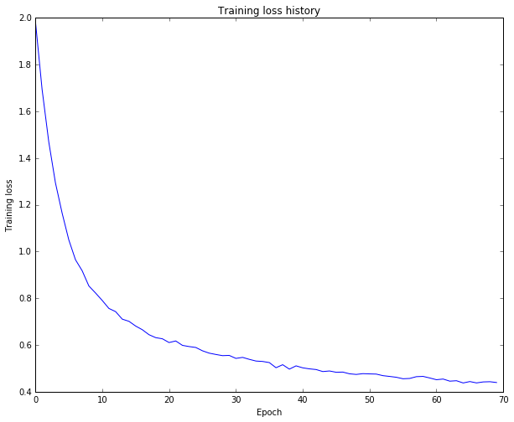

Training/Validation Accuracy

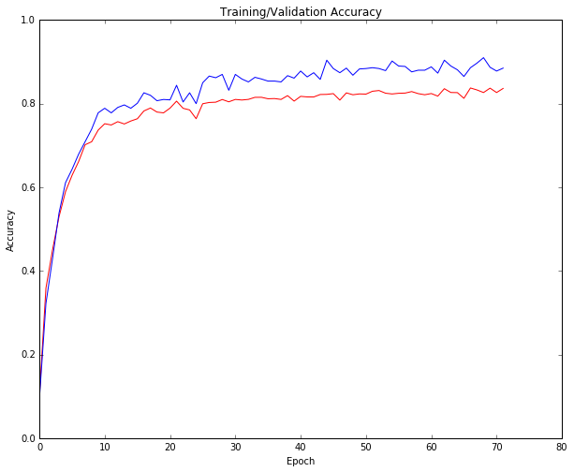

1. CCRN:

**CCRN for the CNN Classifier:**

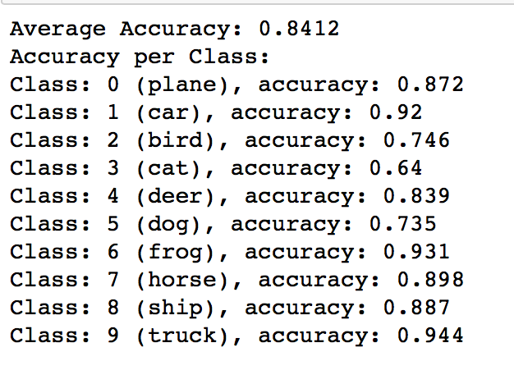

**CCRN for the LLS Classifier:**

Class: 0 ( plane ) , accuracy: 0.469

Class: 1 ( car ) , accuracy: 0.445

Class: 2 ( bird ) , accuracy: 0.207

Class: 3 ( cat ) , accuracy: 0.177

Class: 4 ( deer ) , accuracy: 0.243

Class: 5 ( dog ) , accuracy: 0.285

Class: 6 ( frog ) , accuracy: 0.449

Class: 7 ( horse ) , accuracy: 0.426

Class: 8 ( ship ) , accuracy: 0.508

Class: 9 ( truck ) , accuracy: 0.428

1. ACCR:

First of I achieved 90% Accuracy with the Keras Model. The python file used for training, the model and the IPYNB file for testing the model are included in the (**A3_keras**) Folder.

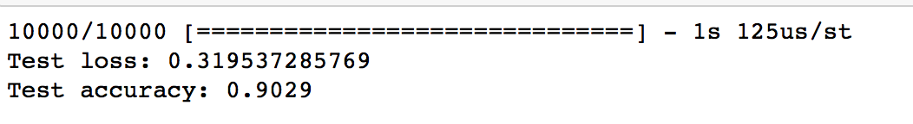

Using My Own Implementation, I achieved: 84.12% which can be seen in the **CNN_5_layers.ipynb** file inside (OWN) Folder.

../../../../Desktop/Screen%20Shot%202018-04-04%20at%2012.15.27%20PM.

**The average should be 87.2%**